EXPERIMENT 6
ARDUINO TO 16x2 LCD DISPLAY USING PROTEUS
AIM: To write an Embedded C program to interface Arduino Uno and 16 x 2 LCD display using Arduino Uno and Proteus.
SOFTWARE REQUIRED: Proteus 8 software; Arduino IDE software
ALGORITHM
- Initialize the 16x2 LCD.
- Display the given message.
- Scroll the display left repeatedly with a delay.
- Continue the scrolling operation in the loop.
PROGRAM
#include <LiquidCrystal.h>
LiquidCrystal lcd(7, 8, 9, 10, 11, 12);
void setup() {
lcd.begin(16, 2);
lcd.print("put your message here");
}
void loop() {
for (int i=0; i<13; i++) {
lcd.scrollDisplayLeft();
delay(700);
}
}
OUTPUT IMAGE

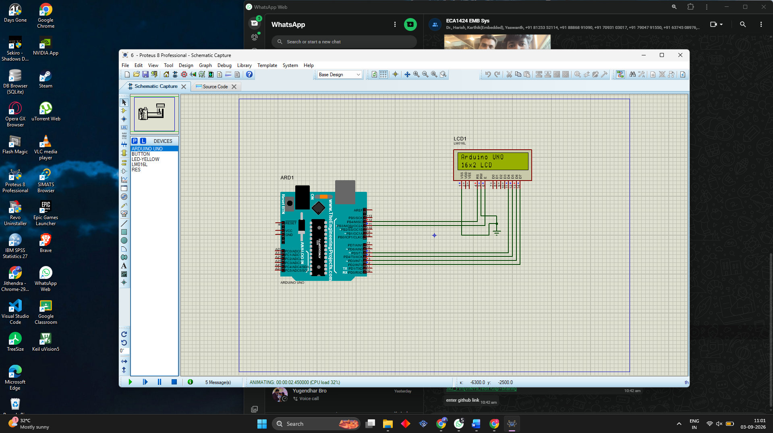
RESULT
Thus the program has been successfully verified and executed.

